Day 32 - 03rd Sept 2025

Name : Aravind Kasanagottu

ID :mvsnarav.

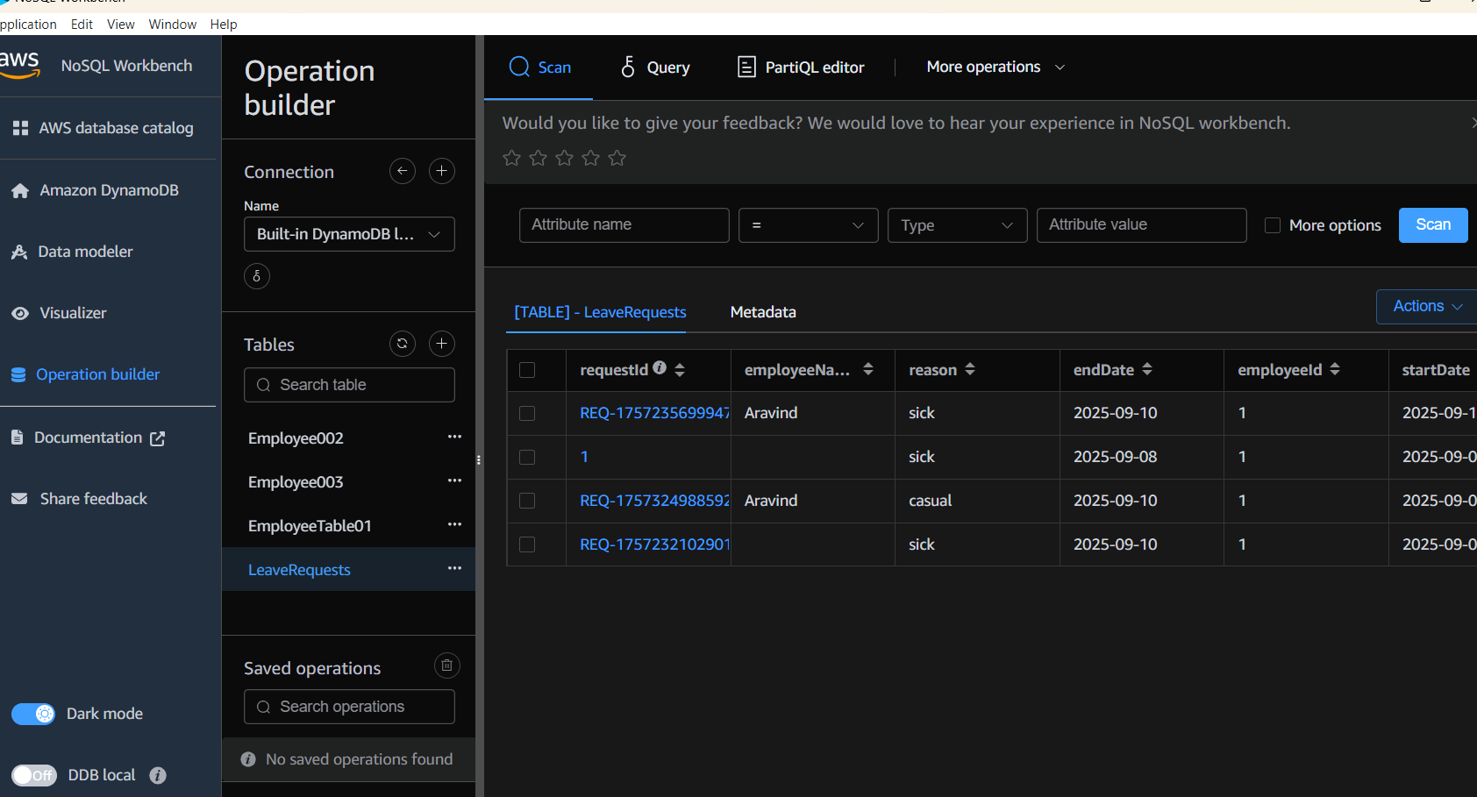

# ============================================================

# ✅ AWS CLI Configuration (One-time setup)

# ============================================================

aws configure

# Provide: Access Key, Secret Key, Region (ap-south-1), Output (json)

# ============================================================

# ✅ Identity Check

# ============================================================

aws sts get-caller-identity

# ============================================================

# ✅ List Tables (to verify before/after creation)

# ============================================================

aws dynamodb list-tables

# ============================================================

# ✅ Task 1: Create Table (Employee)

# ============================================================

aws dynamodb create-table \

--table-name Employee \

--attribute-definitions AttributeName=ID,AttributeType=N AttributeName=EmpName,AttributeType=S \

--key-schema AttributeName=ID,KeyType=HASH AttributeName=EmpName,KeyType=RANGE \

--provisioned-throughput ReadCapacityUnits=5,WriteCapacityUnits=5

# Insert sample data

aws dynamodb put-item \

--table-name Employee \

--item '{"ID": {"N": "1001"}, "EmpName": {"S": "Prasunamba"}}'

aws dynamodb put-item \

--table-name Employee \

--item '{"ID": {"N": "1002"}, "EmpName": {"S": "Meher"}}'

# Query

aws dynamodb query \

--table-name Employee \

--key-condition-expression "ID = :ID" \

--expression-attribute-values '{":ID":{"N":"1001"}}'

# Update

aws dynamodb update-item \

--table-name Employee \

--key '{"ID": {"N": "1001"}, "EmpName": {"S": "Prasunamba"}}' \

--update-expression "set info = :info" \

--expression-attribute-values '{":info": {"S": "MK"}}'

# Delete

aws dynamodb delete-item \

--table-name Employee \

--key '{"ID": {"N": "1001"}, "EmpName":{"S": "Prasunamba"}}'

# Describe Table

aws dynamodb describe-table --table-name Employee

# Scan Table

aws dynamodb scan --table-name Employee

# ============================================================

# ✅ Backup & Restore

# ============================================================

# Create backup

aws dynamodb create-backup \

--table-name Employee \

--backup-name MyEmployeeBackup

# List backups

aws dynamodb list-backups

# Describe a backup

aws dynamodb describe-backup \

--backup-arn arn:aws:dynamodb:ap-south-1:xxxx:table/Employee/backup/xxxx

# Restore table from backup

aws dynamodb restore-table-from-backup \

--target-table-name EmployeeRestored \

--backup-arn arn:aws:dynamodb:ap-south-1:xxxx:table/Employee/backup/xxxx

# ============================================================

# ✅ Home Task: Create Custom Table (EmployeeDetails)

# ============================================================

aws dynamodb create-table \

--table-name EmployeeDetails \

--attribute-definitions AttributeName=EmpID,AttributeType=N AttributeName=EmpName,AttributeType=S \

--key-schema AttributeName=EmpID,KeyType=HASH AttributeName=EmpName,KeyType=RANGE \

--provisioned-throughput ReadCapacityUnits=5,WriteCapacityUnits=5

# Insert 5 records

aws dynamodb put-item \

--table-name EmployeeDetails \

--item '{"EmpID": {"N": "101"}, "EmpName": {"S": "Ravi"}, "Department": {"S": "IT"}, "Salary": {"N": "50000"}}'

aws dynamodb put-item \

--table-name EmployeeDetails \

--item '{"EmpID": {"N": "102"}, "EmpName": {"S": "Sita"}, "Department": {"S": "HR"}, "Salary": {"N": "45000"}}'

aws dynamodb put-item \

--table-name EmployeeDetails \

--item '{"EmpID": {"N": "103"}, "EmpName": {"S": "Meher"}, "Department": {"S": "Finance"}, "Salary": {"N": "60000"}}'

aws dynamodb put-item \

--table-name EmployeeDetails \

--item '{"EmpID": {"N": "104"}, "EmpName": {"S": "Anil"}, "Department": {"S": "Sales"}, "Salary": {"N": "55000"}}'

aws dynamodb put-item \

--table-name EmployeeDetails \

--item '{"EmpID": {"N": "105"}, "EmpName": {"S": "Prasunamba"}, "Department": {"S": "Marketing"}, "Salary": {"N": "47000"}}'

# Query one record

aws dynamodb query \

--table-name EmployeeDetails \

--key-condition-expression "EmpID = :id" \

--expression-attribute-values '{":id":{"N":"103"}}'

# Update salary for EmpID 103

aws dynamodb update-item \

--table-name EmployeeDetails \

--key '{"EmpID": {"N": "103"}, "EmpName": {"S": "Meher"}}' \

--update-expression "set Salary = :salary" \

--expression-attribute-values '{":salary": {"N": "65000"}}'

# Delete EmpID 105

aws dynamodb delete-item \

--table-name EmployeeDetails \

--key '{"EmpID": {"N": "105"}, "EmpName": {"S": "Prasunamba"}}'

# Scan all records

aws dynamodb scan --table-name EmployeeDetails

# ============================================================

# ✅ End of Script

# ============================================================